
Fordcombe Church of England Primary School

Calculation Policy adapted from White Rose Maths Hub

Progression in Calculations – supported with a rich use of vocabulary and discussion throughout

Addition
Vocab
Add, plus, more than, total, sum of, part-part-whole, number line, tens frame, base tens, place value, missing numbers.
Objective and Strategies | Concrete |  | Pictorial | Abstract
Understanding concept of  equality  Balance | Pics of balance beam and scales  3+2=5  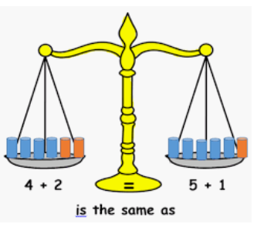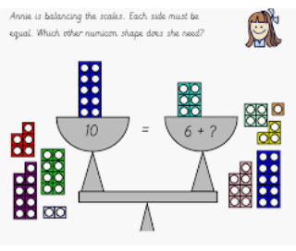  2+?=6 |  | 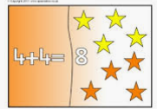 | 4+4 = 8
Combining two parts to make a whole: part- whole model  (Understanding concept of  equality)  Counting and combining | 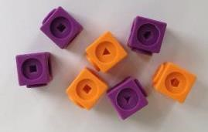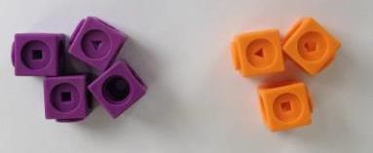 |  | 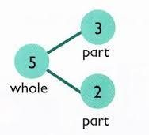  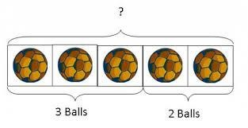 | 4 + 3 = 7  10= 6 + 4    8  5  3
  Use pictures to add two numbers together as a group or in a bar.
    8 |   1
  Use the part-part whole diagram as shown above to move into the abstract.
 | 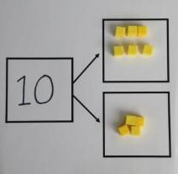  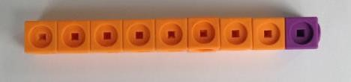 | Use cubes to add two numbers together as a group or in a bar.

Starting at the bigger number and counting  on | 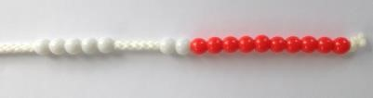  Start with the larger number on the bead string and then count on to the smaller number 1 by 1 to find the answer.  This can also be supported with number tracks.  PIC | 12 + 5 = 17  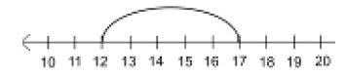  Start at the larger number on the number line and count on in ones or in one jump to find the answer.  Develop to counting on in H’s T’s and U’s  543+243 = 543 + 200 + 40 + 3  PIC of numberline | 5 + 12 = 17  Place the larger number in your head and count on the smaller number to find your answer.
Regrouping to make 10. | 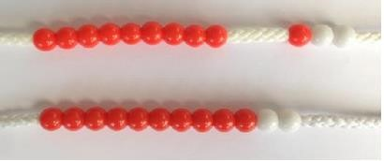  9+3  Use of bead strings or 10 frames  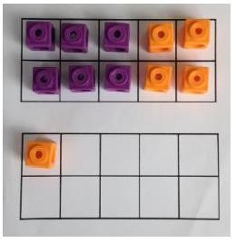  6 + 5 = 11  Start with the bigger number and use the smaller number to make 10 | Use pictures or a number line. Regroup or partition the smaller number to make 10. 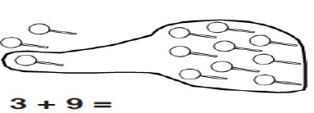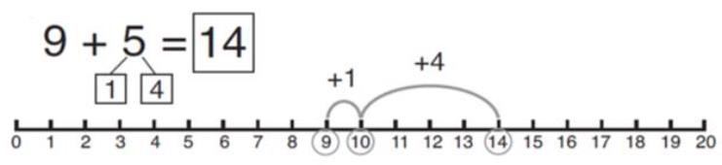 | 7 + 4= 11  If I am at seven, how many more do I need to make 10. How many more do I add on now?

Adding three single digits | 4 + 7 + 6= 17  Put 4 and 6 together to make 10. Add on 7.  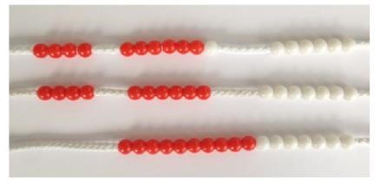  Following on from making 10, make 10 with 2 of the digits (if possible) then add on the third digit. |  +   +   + | 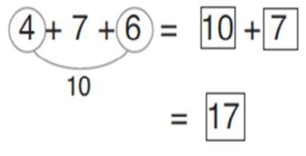  Combine the two numbers that make 10 and then add on the remainder.
  Add together three groups of objects. Draw a picture to recombine the groups to make 10.
Column method- no regrouping  (Partitioning and recombining – no exchanging) | TO + O using base 10. Continue to develop understanding of partitioning and place value.  41 + 8  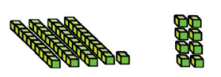  24 + 15=  Add together the ones first then add the tens. Use the Base 10 blocks first before moving onto place value counters.  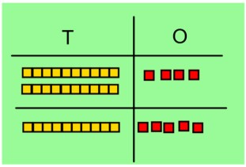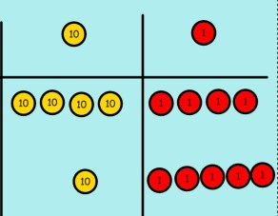 | Children to represent base 10 e.g. lines for tens and dots for ones.  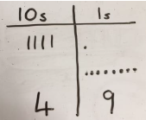  After practically using the base 10 blocks and place value counters, children can draw the counters to help them to solve additions. | 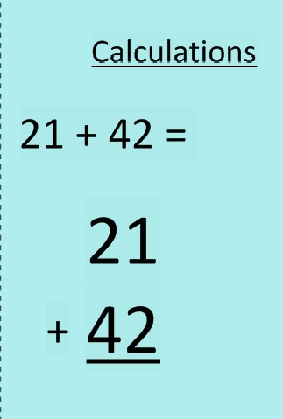
  T | O
Column method- regrouping  (Partitioning with combining) | Make both numbers on a place value grid.  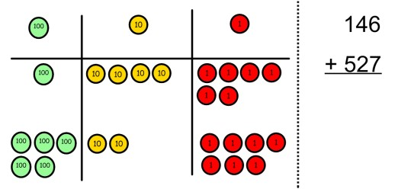  Add up the units and exchange 10 ones for one 10.  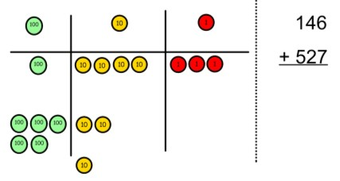  Add up the rest of the columns, exchanging the 10 counters from one column for the next place value column until every column has been added.  This can also be done with Base 10 to help children clearly see that 10 ones equal 1 ten and 10 tens equal 100.  TO + O using base 10. Continue to develop understanding of partitioning and place value.  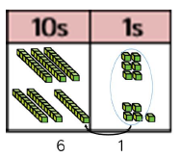  36 + 25  36  +25  _  As children move on to decimals, money and decimal place value counters can be used to support learning. | Children can draw a pictoral representation of the columns and place value counters to further support their learning and understanding.  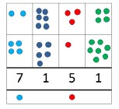 | Start by partitioning the numbers before moving on  to clearly show the exchange below the addition.  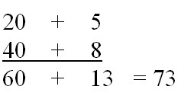  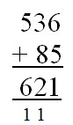  As the children move on, introduce decimals with the same number of decimal places and different. Money can be used here.  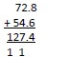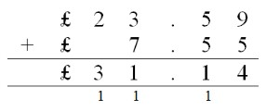  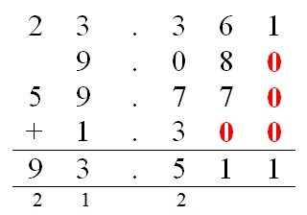
Conceptual Variation  Different ways of solving 21+34 | Word problems:  In year 3, there are 21 children and in year 4, there are 34 children.  How many children in total?  21 + 34 = 55. Prove it | 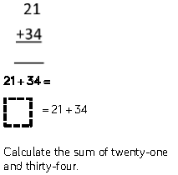 | 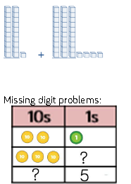
Mental methods | Mental methods should be developed to include increasingly large numbers, fractions and decimals. Methods should by supported by a range of modelling.

Subtraction
Vocab
Take away, less than, the difference, subtract, fewer, minus, decrease, exchange.
Objective and Strategies | Concrete | Pictorial | Abstract
Taking away ones | Use physical objects, counters, cubes etc to show how objects can be taken away.      6 – 2 = 4 | Cross out drawn objects to show what has been taken away.  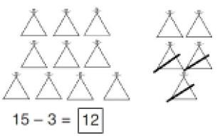 | 18 -3= 15  8 – 2 = 6
Counting back | 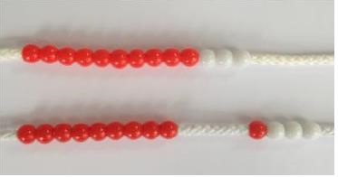  Make the larger number in your subtraction. Move the beads along your bead string as you count backwards in ones.  13 – 4  Use counters and move them away from the group as you take them away counting backwards as you go.  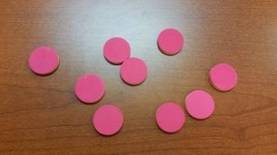 | Count back on a number line or number track  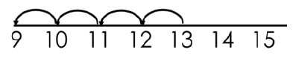  Start at the bigger number and count back the smaller number showing the jumps on the number line.  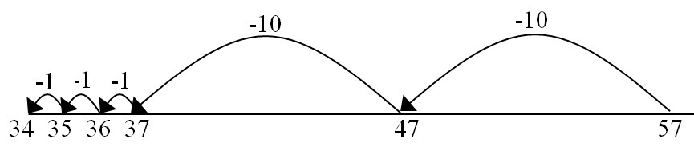  This can progress all the way to counting back using two 2 digit numbers. | Put 13 in your head, count back 4. What number are you at? Use your fingers to help.

Find the difference | Compare amounts and objects to find the difference.  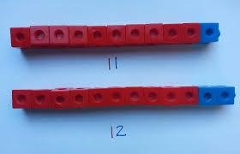  Use cubes to build towers or make bars to find the difference  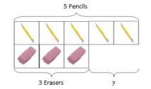  Use basic bar models with items to find  the difference | 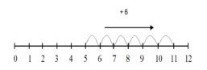  Count on to find the difference.  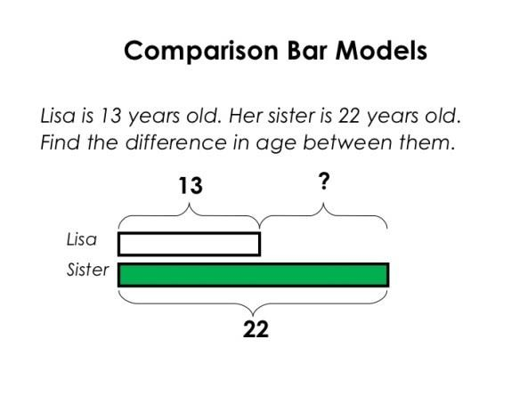  Draw bars to  find the difference between 2 numbers.  72 – 47 =?  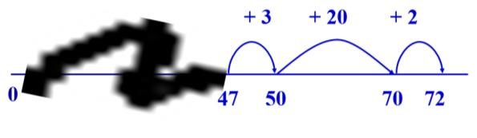 | Hannah has 23 sandwiches, Helen has 15 sandwiches. Find the difference between the number of sandwiches.  Difference between 5 and 3  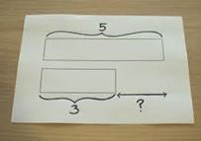
Part Part  Whole Model  (missing number calculations) | 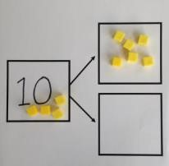  Link to addition- use the part whole model to help explain the inverse between addition and subtraction.  If 10 is the whole and 6 is one of the parts. What is the other part?  10 - 6 = | Use a pictorial representation of objects to show the part part whole model.   |   10  5  Move to using numbers within the part whole model.

Column method without regrouping | Column method using base 10 or place value counters.  48-7  .  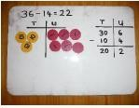  Show how  you partition numbers to subtract.  Again make the larger number first. | Draw the Base 10 or place value counters alongside the written calculation to help to show working  Children to represent the base 10 pictorially.  35 – 23 =  draw the 3 tens and 5 ones  cross out the ones  cross out the tens  look how much remains | 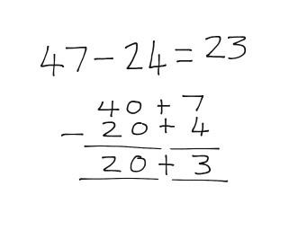  This will lead to a clear written column subtraction.  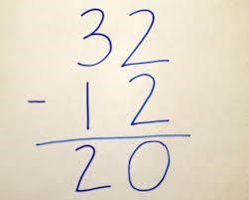

Column method with regrouping | Use Base 10 to start with before moving on to place value counters. Start with one exchange before moving onto subtractions with 2 exchanges.  Column method using base 10 or place value counters and having to exchange.  41 – 26  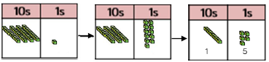  41 Here 1 ten has been Answer  exchanged for 10 ones  Make the larger number with the place value counters  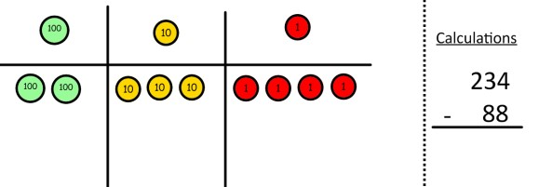  Start with the ones, can I take away 8 from 4 easily? I need to exchange one of my tens for ten ones.  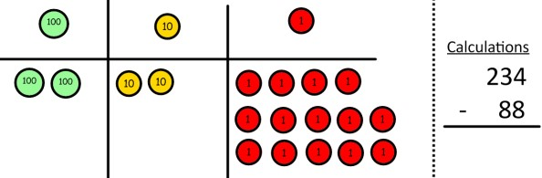  Now I can subtract my ones.  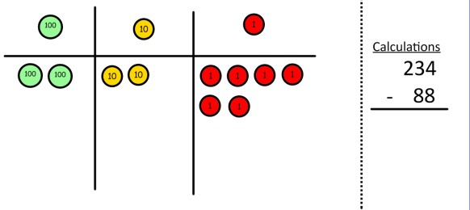  Now look at the tens, can I take away 8 tens easily? I need to exchange one hundred for ten tens. | Represent the place value counters pictorially; remembering to show what has been exchanged.  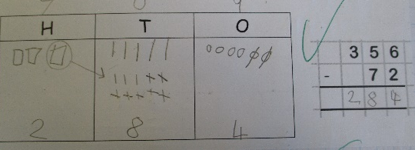  Draw the counters onto a place value grid and show what you have taken away by crossing the counters out as well as clearly showing the exchanges you make.  When confident, children can find their own way to record the exchange/regrouping.  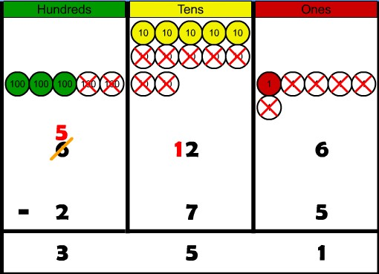  Just writing the numbers as shown here shows that the child understands the method  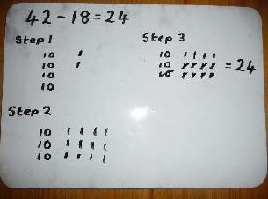  and knows when to exchange/regroup. | 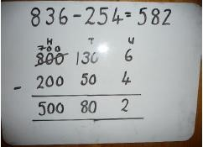  Children can start their formal written method by partitioning the number into clear place value columns.  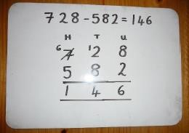  Moving forward the children use a more compact method.  This will lead to an understanding of subtracting any number including decimals.  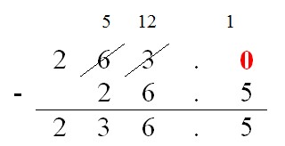
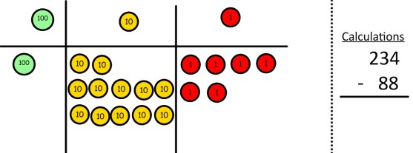
Now I can take away eight tens and complete my subtraction

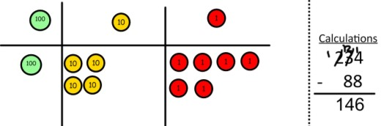

Show children how the concrete method links to the written method alongside your working. Cross out the numbers when exchanging and show where we write our new amount.
Conceptual Variation  Children are asked to use different ways to solve 391-186 |  | Raj spent £391, Timmy spent £186.  How much more did Raj spend?  Calculate the difference between 391 and 186 | = 391 – 186  What is 186 less than 391  Missing digit calculations
Mental methods | Mental methods should be developed to include increasingly large numbers, fractions and decimals.  Methods should by supported by a range of modelling.

Multiplication
Vocab
Double, times, multiplied by, the product of, groups of, lots of, equal groups, exchange
Objective and Strategies | Concrete | Pictorial | Abstract
Doubling | Use practical activities to show how to  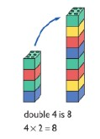  double a number.  Considering groups / lots of the same size | Draw pictures to show how to double a number emphasising groups/lots of the same amount/value  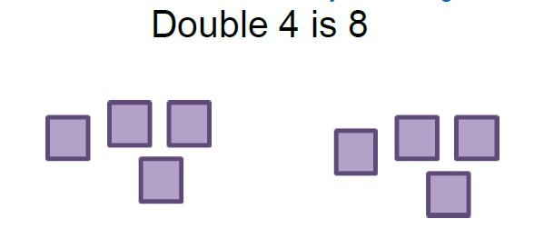  Double £6  £6 + £6 = £12 | 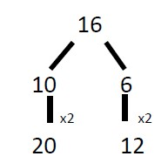  Partition a number and then double each part before recombining it back together.
Counting in  multiples  (develop the concept of scaling – 3 times taller/bigger/heavier etc) | 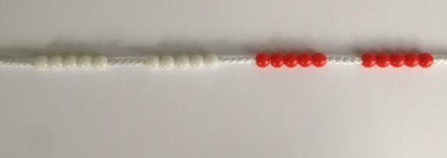  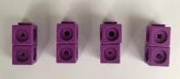  Count in multiples supported by concrete objects in equal groups. | 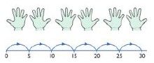  Use a number line or pictures to continue support in counting in multiples. | Count in multiples of a number aloud.  Write sequences with multiples of numbers.  2, 4, 6, 8, 10  5, 10, 15, 20, 25 , 30  Develop to counting in multiples of 6, 7, 9, 25, 100,  1000, 1/10, 1/100

Repeated addition  (Relating to ‘times’ and othre rich  vocabulary)  Jumping in groups | 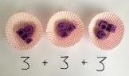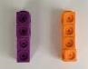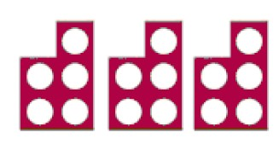  Use different  objects to add  equal groups.  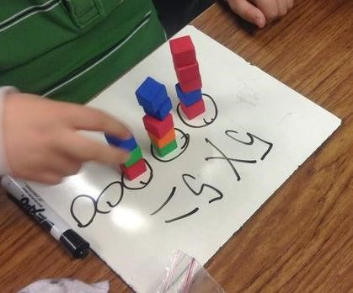 | 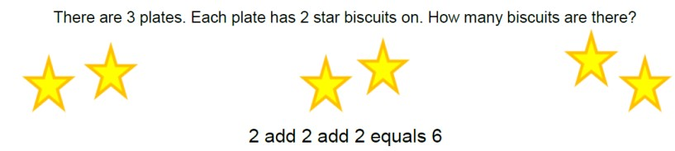  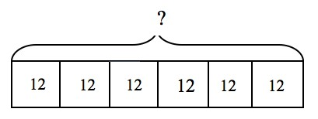  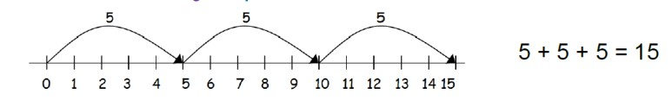 | Write addition sentences to describe objects and pictures.  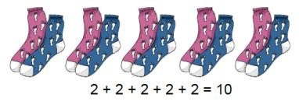
Arrays- showing  commutative multiplication | Create arrays using counters/ cubes to show multiplication sentences.  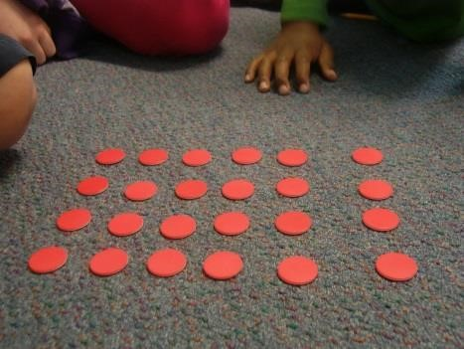  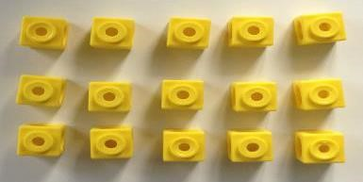 | 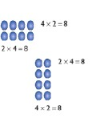  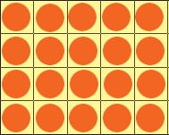  Draw arrays in different rotations  to find commutative multiplication sentences.  Link arrays to area of rectangles.  (can use numberline to add ‘lots of’) | Use an array to write multiplication sentences and reinforce repeated addition.  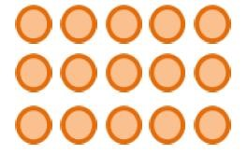  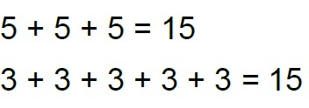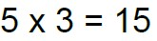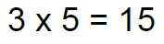

Multiply by 10, 100, 1000 | Pics of diens  2 x 10  (2 units becomes 2 rows of 10 ) | HTU columns  Extend to use of decimal place value | Able to recognise place  value shift  5x10= 50  16x100= 1600  1.5x10 = 15
Grid Method  (refer to groups and  lots) | Show the link with arrays to first introduce the grid method.  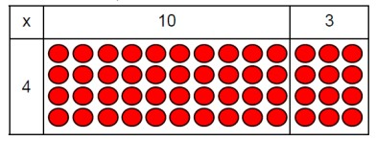  4 rows of 10 4 rows of 3  Move on to using Base 10 to move towards a more compact method.  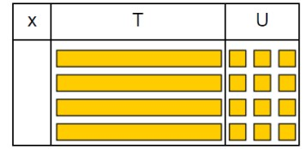  4 rows of 13  Move on to place value counters to show how we are finding groups of a number.We are multiplying by 4 so we need 4 rows.  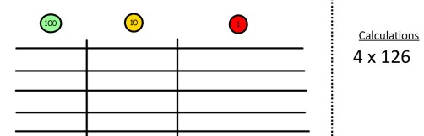  Fill each row with 126.  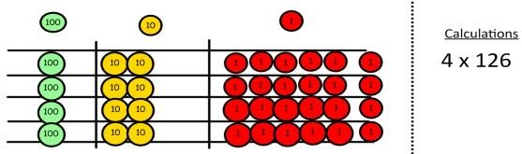  Add up each column, starting with the ones making any exchanges needed.  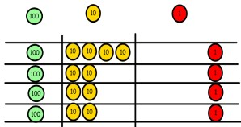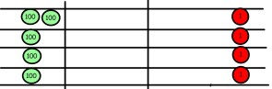  Then you have your answer. | Children can represent the work they have done with place value counters in a way that they understand.  They can draw the counters, using colours to show different amounts or just use circles in the different columns to show their thinking as shown below.  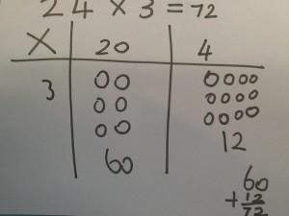 | Start with multiplying by one digit numbers and showing the clear addition alongside the grid.  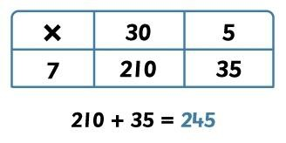  Moving forward, multiply by a 2 digit number showing the different rows within the grid method.  18 x 13  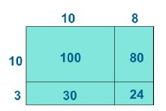  1342 x 18  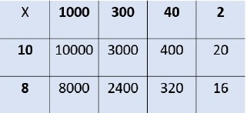  Children develop the use of blank arrays to solve problems like  2 x 5 = 160
  ? | 2
  150 | 10

Column  multiplication | Children can continue to be supported by place value counters at the stage of multiplication.  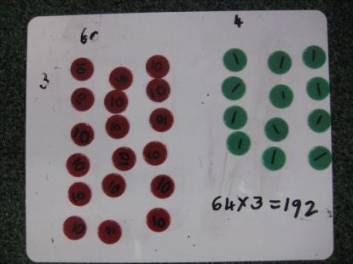  It is important at this stage that they always multiply the ones first and note down their answer followed by the tens which they note below. | Bar modelling and number lines can support learners when solving problems with multiplication alongside the formal written methods.  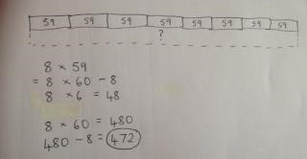  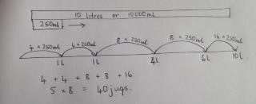 | Start with long  multiplication, reminding the children about lining up their numbers clearly in columns.  If it helps, children can write out what they are solving next to their answer.  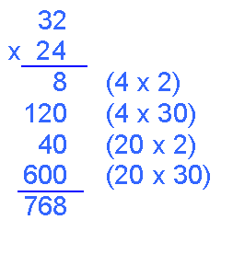  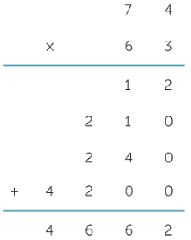  This moves to the more compact method.  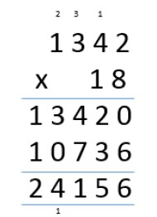
Conceptual Variation  Different ways to ask children to solve 23x6 |  | Meg had to swim 23 lengths, 6 times a week. How many lengths did she swim in one week?  With counters, or tens and one, prove that 23x5=138  Find the product of 6 and 23.  6x23=  ….. = 6x23  6 23  x 23 x 6 | What is the calculation?  What is the product?

Division
Vocab
Share, group, divide, divided by, half, divisor, dividend, quotient, remainder, exchange.
Objective and Strategies | Concrete | Pictorial | Abstract
Division as sharing  Relate to  fractions  Eg ½ means 2 groups etc | 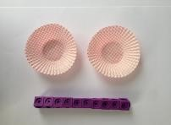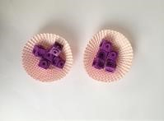  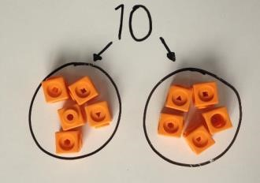  I have 10 cubes, can you share them equally in 2 groups? | Children use pictures or shapes to share quantities.   | Share 9 buns between three people.  9 ÷ 3 = 3
  8 ÷ 2 = 4
Division as  grouping  (How many 3s in 9?) | Divide quantities into equal groups. Use cubes, counters, objects or place value counters to aid understanding.  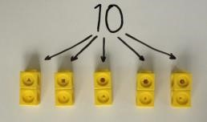  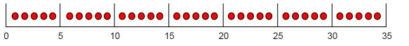  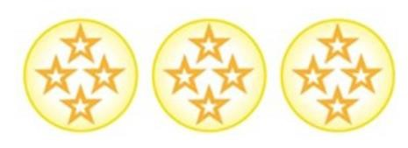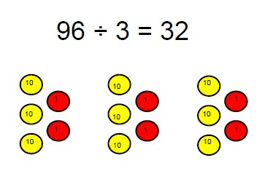 | Use a number line to show jumps in groups. The number of jumps equals the number of groups.  12÷3 (how many  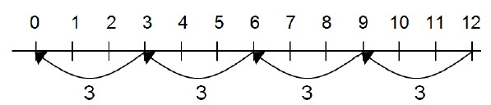  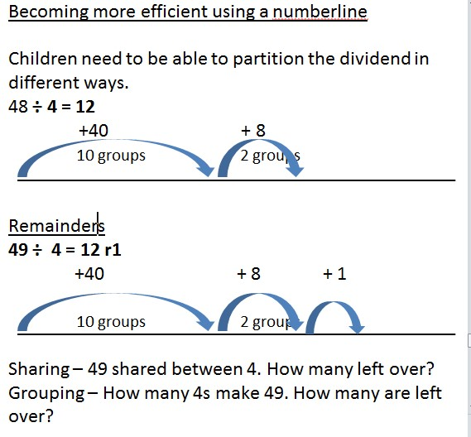 | 28 ÷ 7 = 4  Divide 28 into 7 groups. How many are in each group?

Division within arrays  (solve missing  number calculations)  Also relate to  fractions – eg 1/3  means 3 (3rows) | 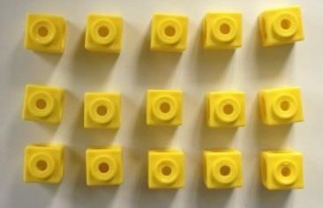  Link division  to multiplication by creating an array and thinking about the  number sentences that can be created.  Eg 15 ÷ 3 = 5 5 x 3 = 15  15 ÷ 5 = 3 3 x 5 = 15 | 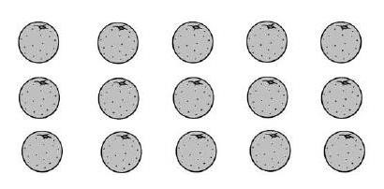Draw an array and use lines to split the array into groups to make multiplication and division sentences.  Develop forward to using blank arrays 18÷6 =  ?  6  Link to fractions 1/8 of 32  ?  8  Develop 3/8 will be three of the groups of 1/8 | Find the inverse of multiplication and division sentences by creating four linking number sentences.  7 x 4 = 28  4 x 7 = 28  28 ÷ 7 = 4  28 ÷ 4 = 7  Use to solve missing  number problems  ? ÷ 4 = 9 9 x 4 = ?
  18
  32

Division with a remainder | 14 ÷ 3 =  Divide objects between groups and see how much is left over  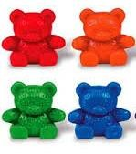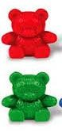 | Jump forward in equal jumps on a number line then see how many more you need to jump to find a remainder.  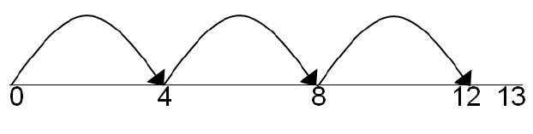  Draw dots and group them to divide an amount and clearly show a remainder.  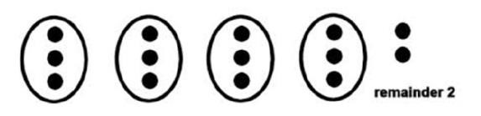 | Complete written divisions and show the remainder using r.  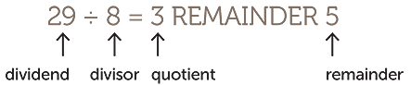
Short division | 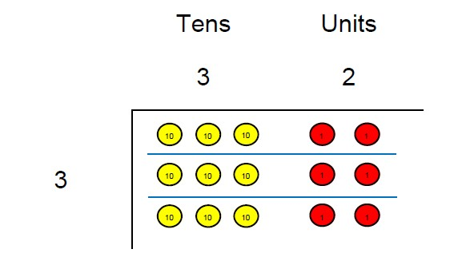  96÷3  Use place value counters to divide using the bus stop method alongside  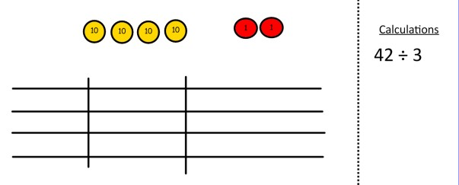  42 ÷ 3= | Students can continue to use drawn diagrams with dots or circles to help them divide numbers into equal groups.  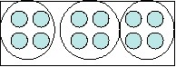  Encourage them to move towards counting in multiples to divide more efficiently. | Begin with divisions that divide equally with no remainder.  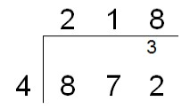  Move onto divisions with a remainder.  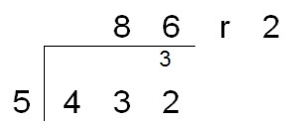
 | Start with the biggest place value, we are sharing 40 into three groups. We can put 1 ten in each group and we have 1 ten left over.  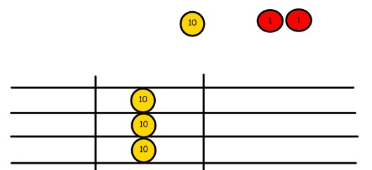  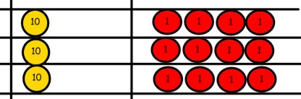  We exchange this ten for ten ones and then share the ones equally among the groups.  We look how much in 1 group so the answer is 14. | 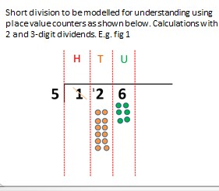 | Finally move into decimal places to divide the total accurately.  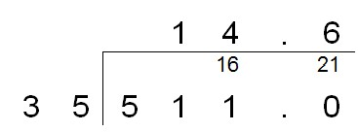
Conceptual Variation  Different ways to ask children to solve 615 divided by 5. | Using the part whole model below, how can you divide 615 by 5 without using short division? | I have £615 and share it equally between 5 bank accounts. How much will be in each bank account?  615 pupils need to be put into 5 groups. How many will be in each group?  615 ÷ 5 = __  __ = 615 ÷ 5 | What is the calculation?  What is the answer?

Fractions

Year 1

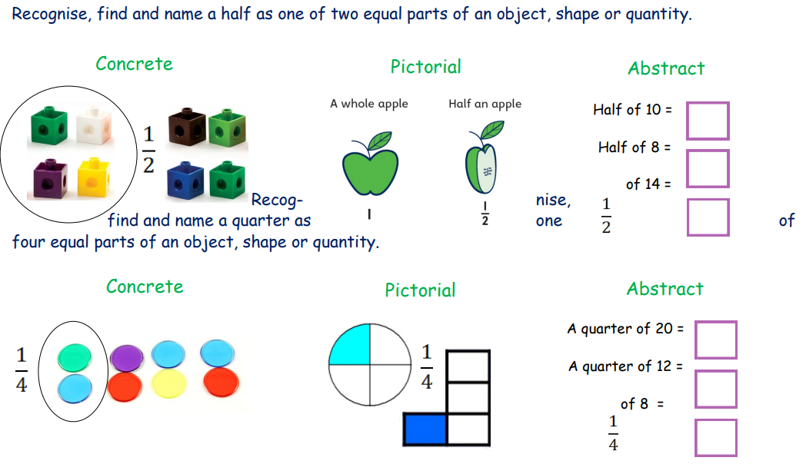

Year 2

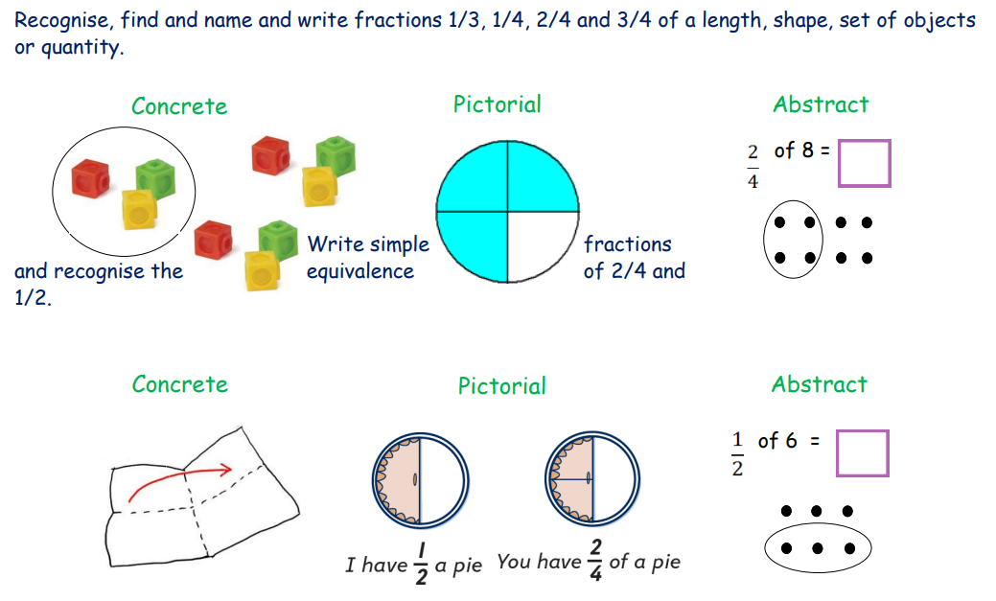

Year 3

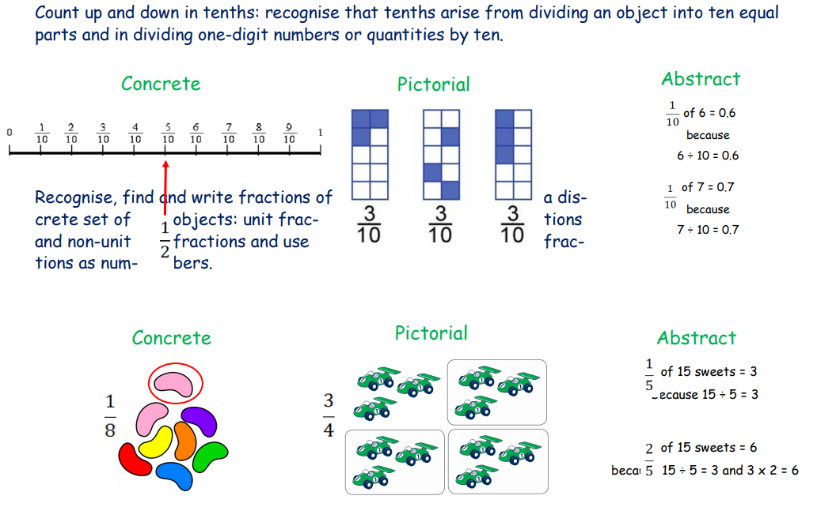

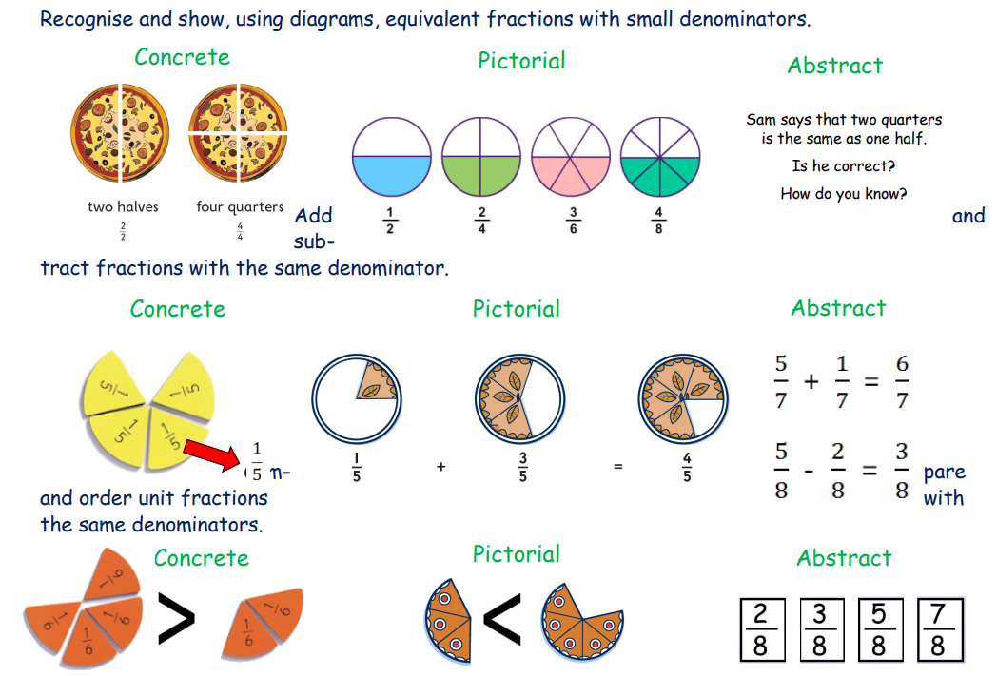

Year 4

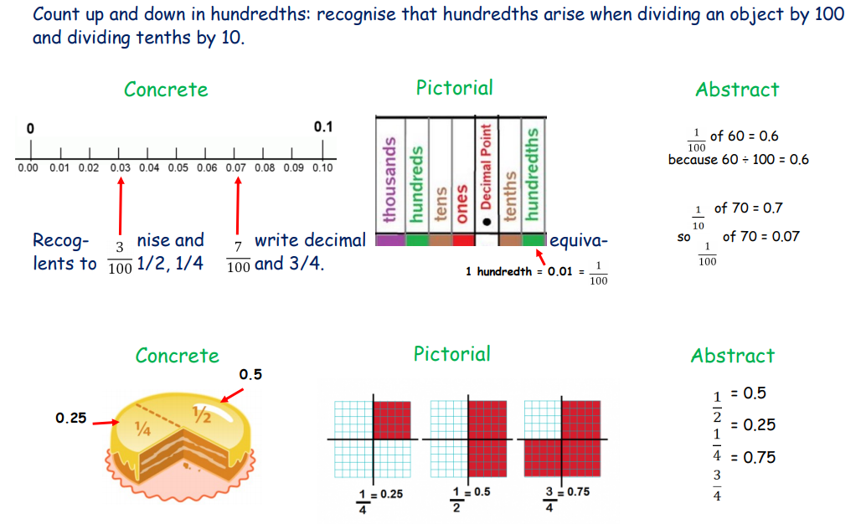

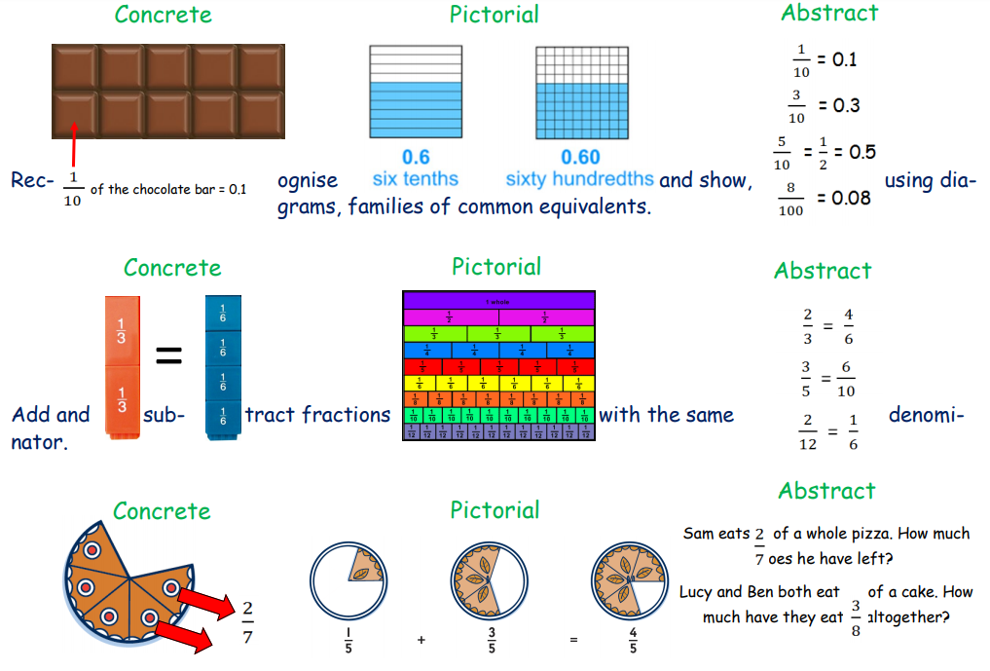

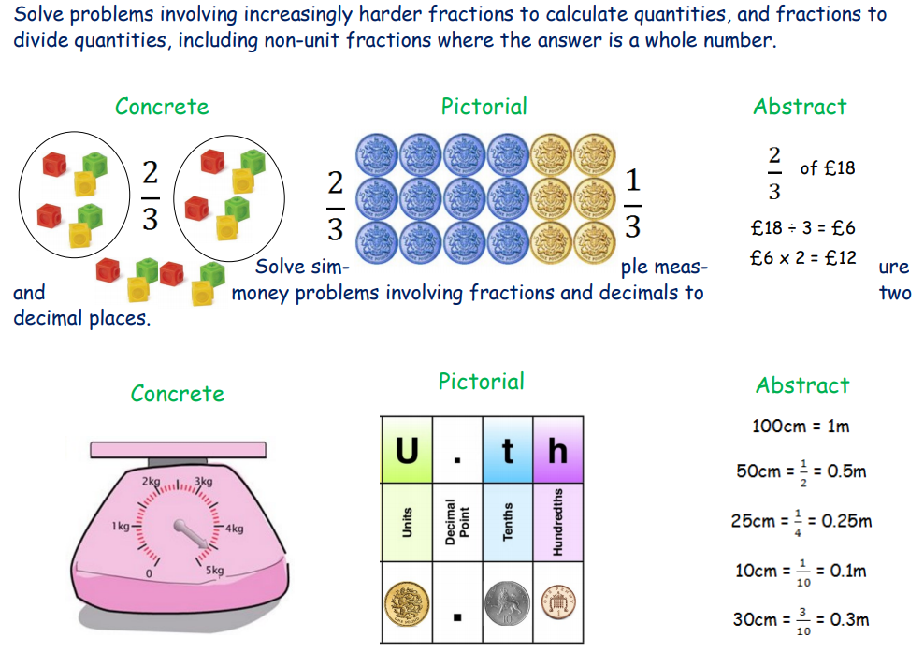

Year 5

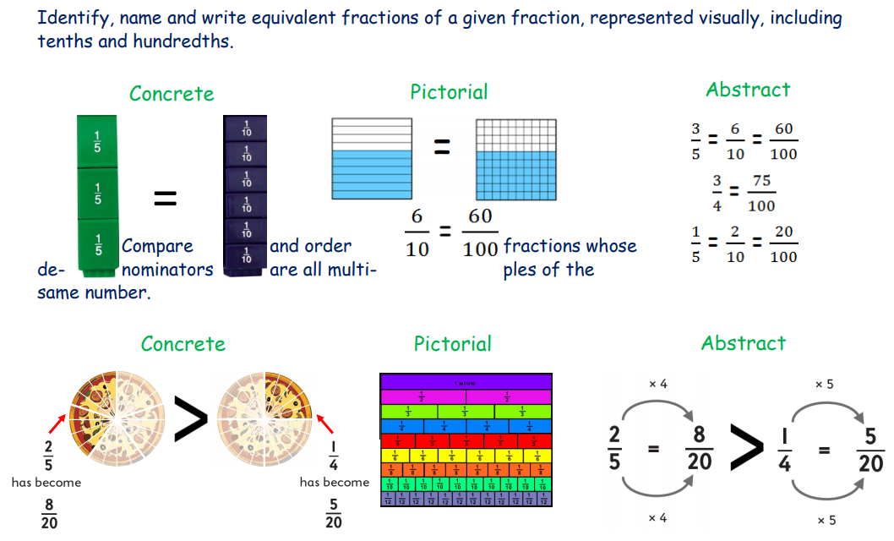

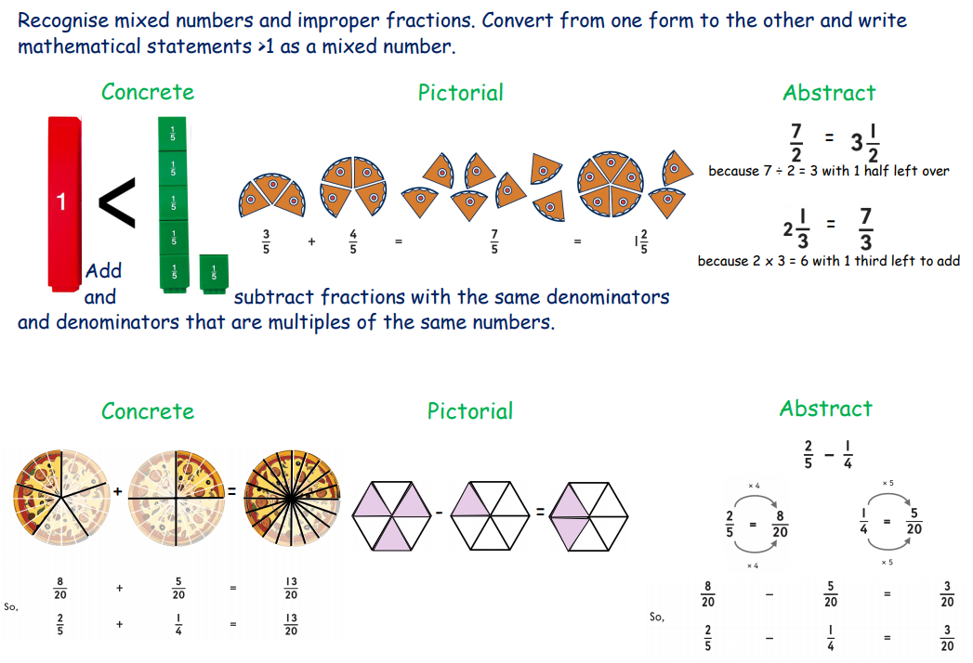

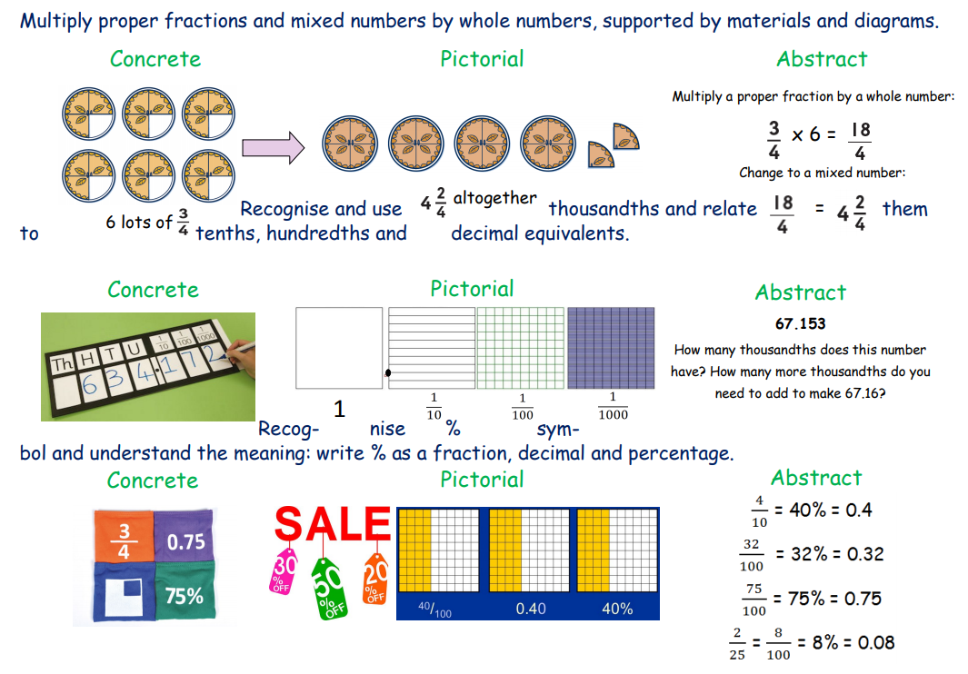

Year 6



